INTERREGIONAL NON-GOVERNMENTAL ORGANISATION
THE READING ASSOCIATION OF RUSSIA

rusreadorg.ru
MARGARITA RUDOMINO ALL-RUSSIA STATE LIBRARY FOR FOREIGN LITERATURE РУДОМИНО
libfl.ru

Information Letter

Distinguished colleagues,
We are pleased to invite you to The 8th International scientific and practical сonference 'Reading and Literacy in Education and Culture: a regional perspective and global vision'.
The conference will take place in the hybrid format with in person and online participation.

Background
For 25 years, the conferences 'Reading and Literacy in Education and Culture' have been a forum for discussing key issues in the area of reading and literacy, have helped share findings in this sphere, and examine new reading practices. Our effort to share the best practices helps to enhance the work of the Association's regional divisions – schools, universities, and libraries – by applying the solutions on the ground, while also enriching our common experience.
The 2022 Conference will do more to promote reading among people of different age groups at the regional, national and international levels, and to set forth new principles that conflate regional needs with a global vision.
The conference will address a wide range of issues:
- the regional constituent in school and tertiary education, and its effect on readers' practices;
- the regional constituent in the work of libraries in combination and/or in conjunction with nation-wide programmes;
- modern global challenges and questions of reader agency;
- measures to support reading in the Russian language in the regions;
- promotion of the Russian language and literature abroad;
- reading in small peoples' languages;
- interdisciplinary reading research;
- reading and Digital Humanities;
- reading pragmatics and communications in the modern world.
We would like to engage stakeholders in the area of reading and literacy representing public and civil society organization of the Russian Federation and the CIS nations, as well as young researchers interested in these questions.
Venue
The Conference will take place in Margarita Rudomino All-Russian State Library for Foreign Languages, Moscow Nikoloyamskaya Street, building 1.

The participation in the conference is free of charge. Traveling expenses will be covered by the participant's organization.

A participant's conference bag will contain a collection of scholarly papers 'Homo legens–14'.

We welcome exclusive manuscripts for publication on the topics included into the programme of 'The Reader Mastery Academy – 2022' held March 25–26, 2022 and The 8th International scientific сonference 'Reading and Literacy in Education and Culture: a regional perspective and global vision' to be held October 28, 2022.

We publish several categories of material:
- reports of the plenary and breakout sessions of 'The Reader Mastery Academy' and the Conference;
- articles written by the members of the Reading Association of Russia who have submitted membership fees;
- scripts of workshops presented at 'The Reader Mastery Academy', and the abstracts of reports to be presented at the Conference.

An article is up to 30,000 spaced printed characters, and an abstract is a 200–250-word text.
To learn more about the formatting requirements, please click the link to an article sample.

Submissions may be uploaded through an account at the conference web site http://conference-mbco.ru, or sent to the e-mail address rusreadorg@gmail.com.

Key dates
10.04– 31.08.2022 | Registration of the presenting conference participants  via an account at https://conference-mbco.ru
10.04–  31.08.2022 | Submission of abstracts and articles to be published in the collection of scholarly papers 'Homo legens–14'. Submissions are uploaded via an account at https://conference-mbco.ru or sent to rusreadorg@gmail.com
10.04– 03.10.2022 | Registration of the non-presenting conference participants
28.10.2022 | The work of the Conference
after 28.10.2022 | Certificates of the conference presenters will be sent to the e-mail address of the participant provided by him or her during the registration.
 | Certificates of the conference participants will be downloaded through the account at the conference web site http://conference-mbco.ru
*To obtain a certificate, participants should register at the conference web site.

Organization committee conference.mbco@gmail.com

An article sample for the authors of
'Homo legens–14' Homo legens-14»

INTERACTIVE METHODS OF TEACHING THE READING OF FICTION
IN CLASSROOMS AND IN THE DIGITAL ENVIRONMENT
NATALIA KULIBINA
Doctor of Pedagogy, Professor,
Head of the Methodological Department of the Russian Language
of Pushkin State Russian Language Institute
Russia, Moscow
Abstract. The article describes the main provisions of an interactive methodology for teaching fiction reading in face-to-face classes and in a digital environment: the use of authentic literary texts, taking into account the universal psychological mechanisms of reading activity and organizing a reading lesson according to the model of natural speech interaction between the reader and the book. …
Keywords: Interactivity, methodology, reading, fiction ...

There is a widespread idea that interactive learning results from the application of gadgets. However, this is not borne out by facts. Digital technologies only help to maximize the benefits of the learning material that was worked through by the teacher.
…
A text is interactive by nature: it poses questions, encouraging a reader to search for answers. Leontiev called a text a 'communication act waiting to unfold', which has all the elements of a communication situation, such as interlocutor 1 (the author), interlocutor 2 (the reader), the message (the text) [6]. This assertion is true for any text, including literary, which apart from all the textual features is communicative by nature. Lotman wrote that a literary text was "an ideal communication partner," facilitating a reader's comprehension and giving him the clues necessary for understanding: "As if a text and a reader were in search of mutual understanding. They "accommodate" each other. A text is akin to an interlocutor partaking in a dialogue: it allows for restructuring (within the limits of internal structural uncertainty) under the influence of the audience" [7, p. 113].
To learn to understand fiction means to master the techniques of interaction with a text, interaction through a text. Reading instruction may be provided in class or at home; to any group of people that needs this skill (children and adults; native and non-native speakers, as well as bilinguals; children with speaking difficulties etc.); ...
…
We would like to draw the attention of the authors that
screenshots containing visual data should not be added to the submitted text.
Visuals will appear as black and white images on paper.
Visuals may be requested by the editor in a separate jpeg file.

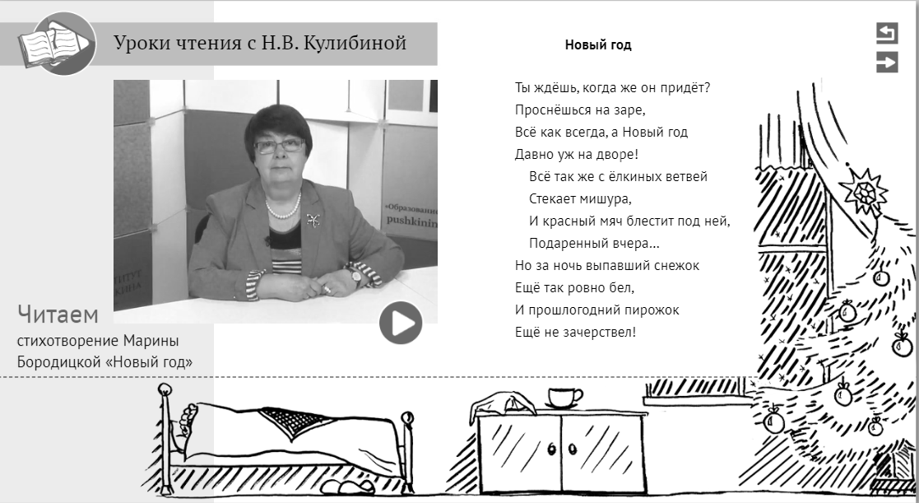
Picture 1. An online lesson on the poem 'New Year' by M. Boroditskaya. Бородицкой «Новый год»
We would like to draw the attention of the authors that
the sources in the bibliography shoud be arranged in the alphabetic order.
______________________
- Zhinkin N. Rech kak provodnik informatsii. Moskva: Nauka, 1982.
- Issledovanie PISA-2009. Resultaty. http://www.centeroko.ru/pisa09_res.htm. P. 25.
- Kulibina N. Zachem, chto i kak chitat na uroke? Khudozhestvenny tekst pri izuchenii russkogo yazyka kak inostrannogo. Sankt-Peterburg: Zlatoust, 2015.
- Kulibina N. Metodika obuchenia chteniyu khudozhestvennoi literatury. Monografia. Moskva: Flinta, 2018.
- Kulibina N. Chitaem po-russki na urokakh. Kniga dlya uchilelya. Kniga dlya uchenikov. Riga: RETORIKA-A, 2008.
- Kulibina N. Chitaem stikhi russkikh poetov. Uchebnoe posobie (6-e izd.). Sankt-Peterburg: Zlatoust, 2019.
- Leontiev A. Osnovy psikholingvistiki. Moskva: Smysl, 1999.
- Lotman Yu. Vnutri myslyachshikh mirov. Chelovek, tekst, semiosfera, istoria. Moskva: Yazyki russkoi kultury, 1999.
- Smith F. Understanding Reading: A Psycholinguistic analysis of reading and learning to read. New York, 1971.

